**Create React front-end application:**

command: npx create-react-app my-app

Where my-app is the name of application;

To check if everything is fine, we use npm start;

**Display List in recact:**

1- Create Component List and ListItem.

2- Create JSON array in the App componenets contains the data that we want.

3- Import and initialize the useSatate to store the JSON object.

4- Check if the JSON array is empty and ask youser to create Item.

5- Call the ListItem component inside List component.

6- Loop using map function over the JSON array and send values as props to ListItem.

7- Recive the content of list in ListItem component to display them using props.

* ***code of List.js:***

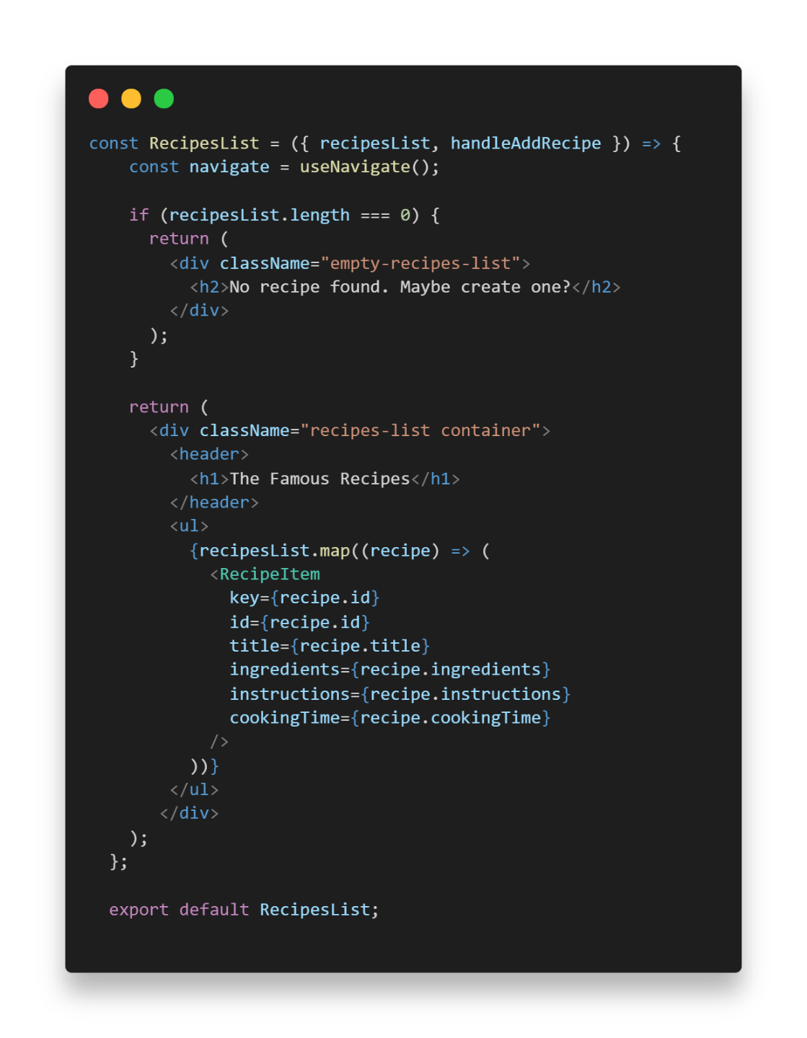

* ***code of ListItems.js:***

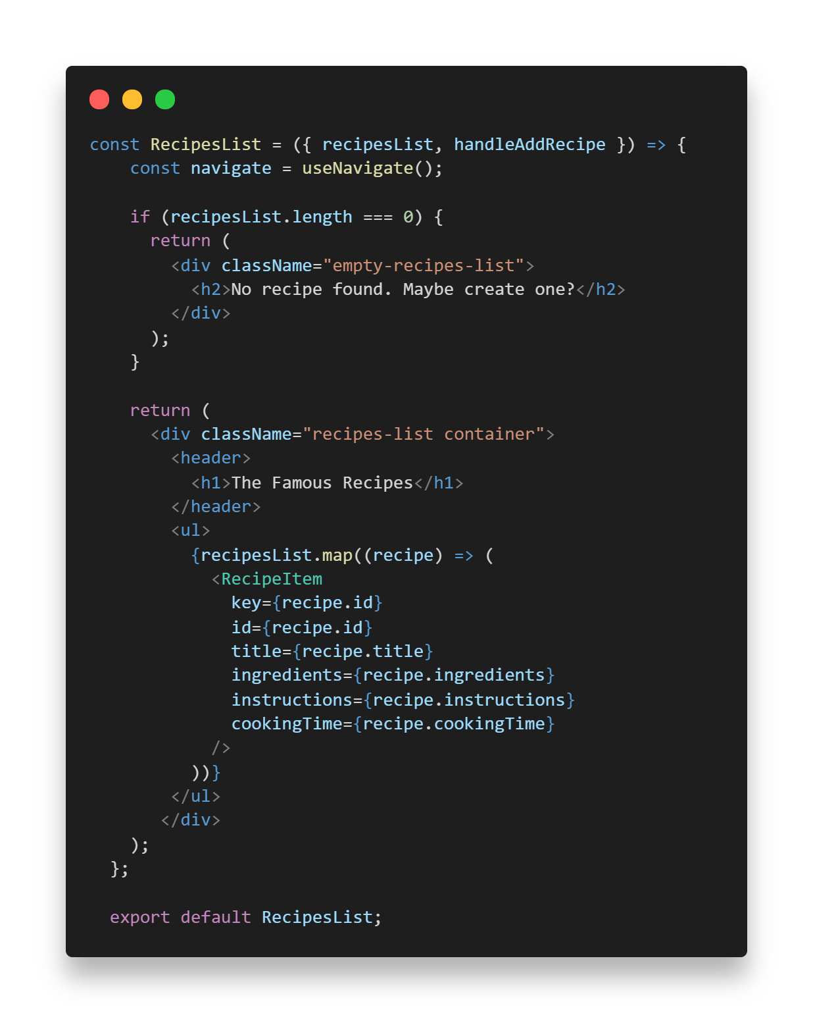

* ***code of App.js:*** 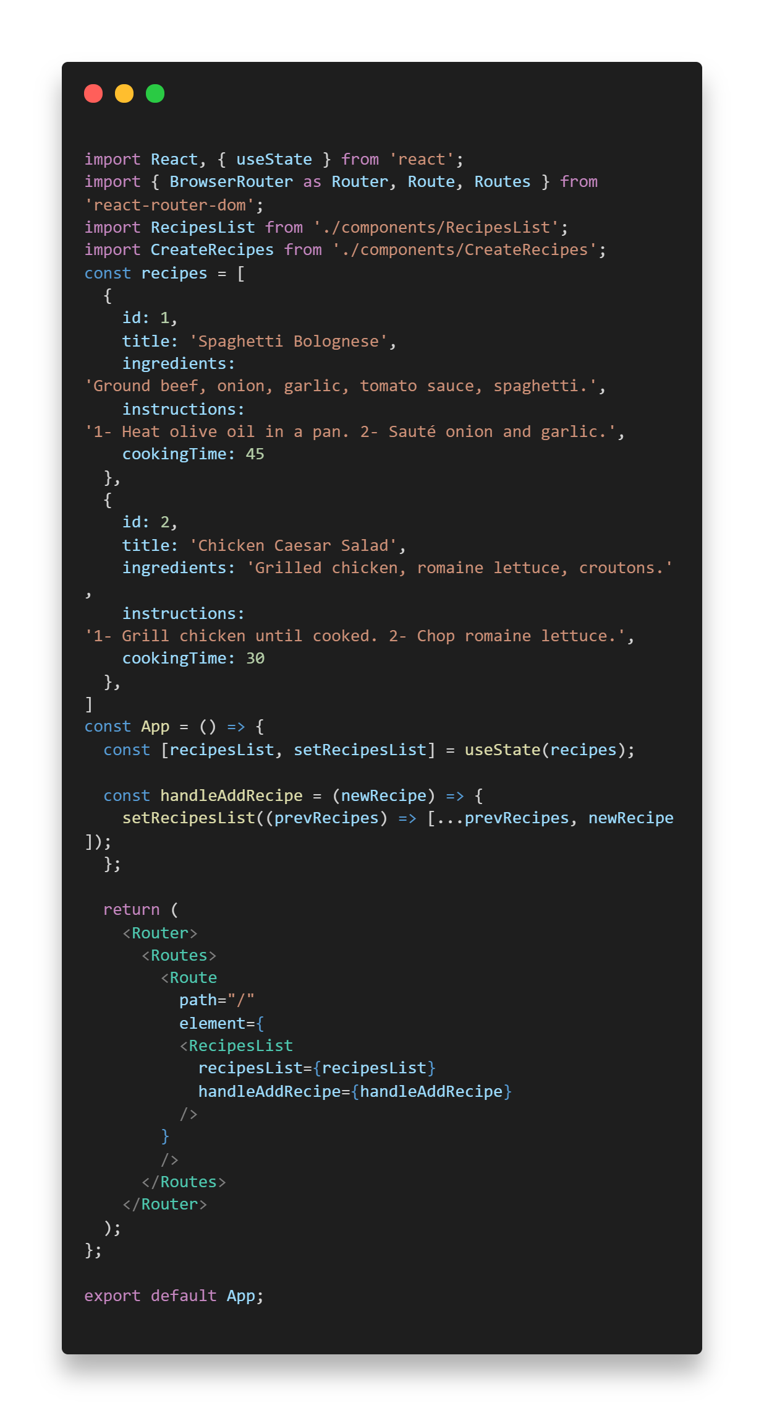

**Create new item list in recact:**

1-Create component specific for creation.

2-Create new form that handle new inputs.

3-Initialize state variable with empty string values

4-Create function that handle every change in inputs and combine old values in the list with the new values from inputs.

5-Create function when we click save data that store new values, make variable empty and redirect to home list page.

6-Add new route in App.js component that redirect to create component

7-Create function that handle added items in the list and combine the old list items with new item.

8-Pass this function to List component in order to update the list and create component.

* ***code of createItem.js:***

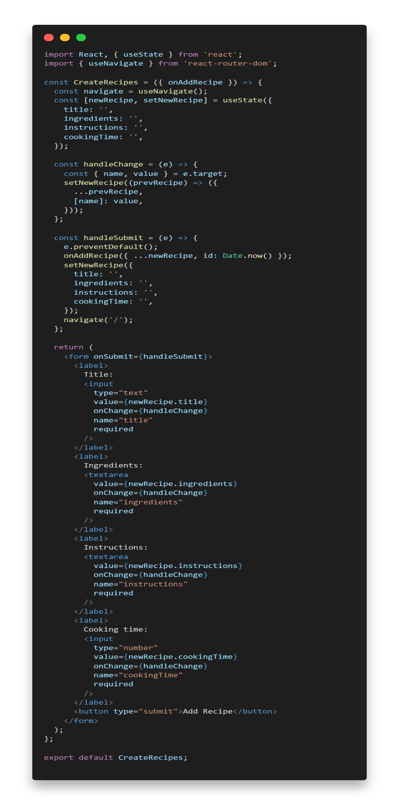

* ***code of App.js:***

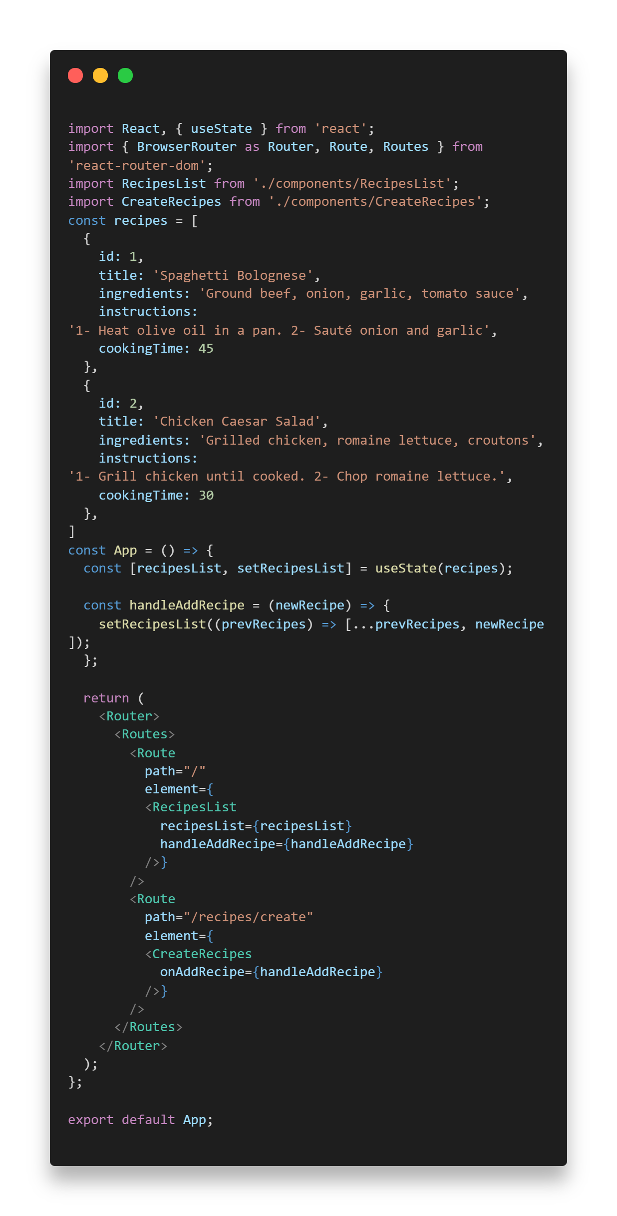

**Delete item list in recact:**

1-Add delete button in itemList.js

2-Add function in itemList.js that handle id of desired deleted item using props.

3-Call this function on click event when button clicked.

4-Pass function as parameter to handle delete in List.js to update list after delete item from parent component.

5-Pass function to itemList.js component as Props to handle the function in the child component.

6-In the App.js component create function that filter the list using id and remove the desired item.  
7-Pass this function as props to list component.

* ***code of ListItem.js:***

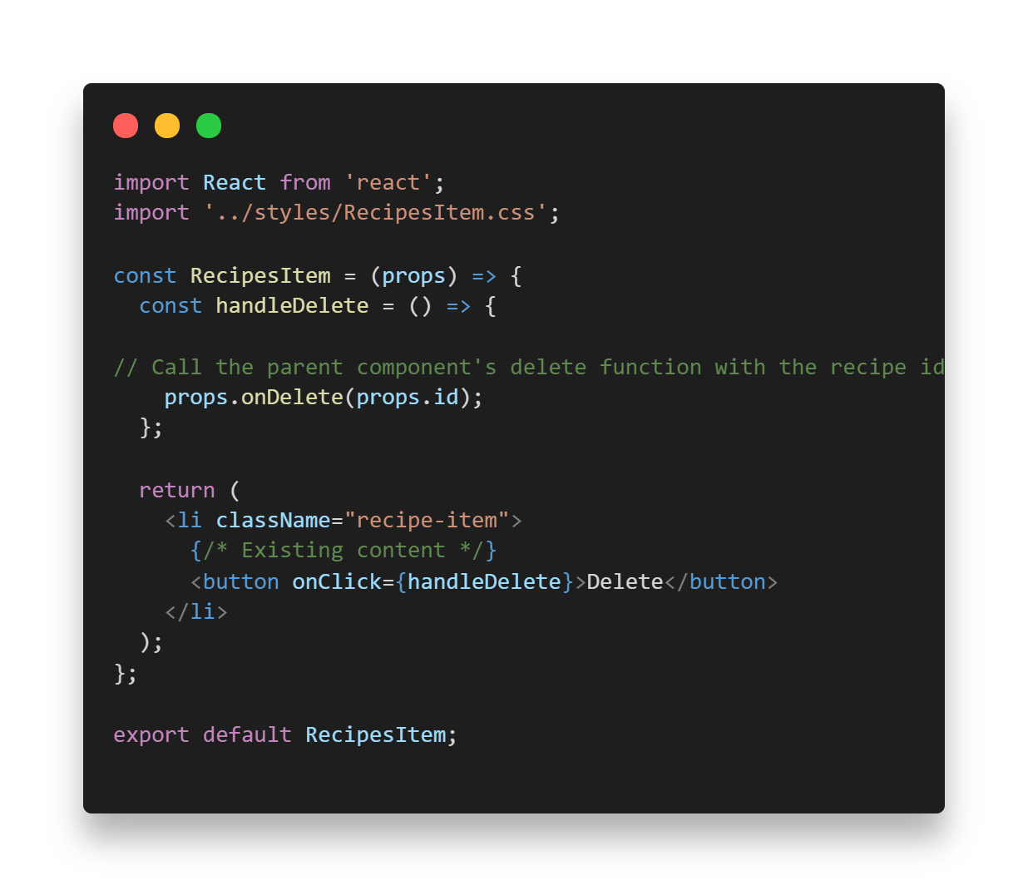

* ***code of List.js:***

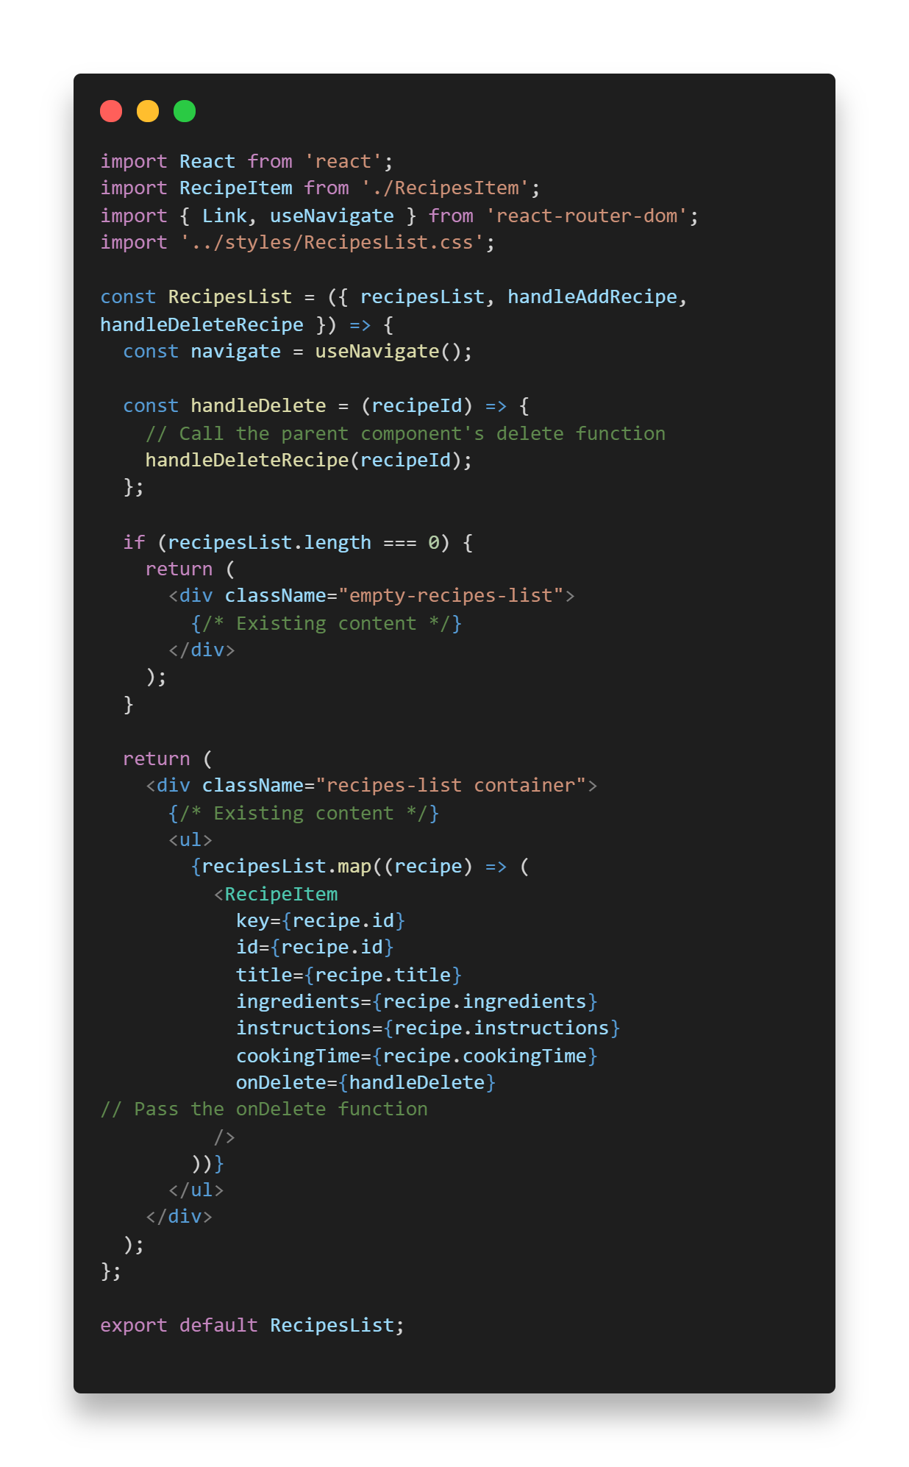

* ***code of App.js:***